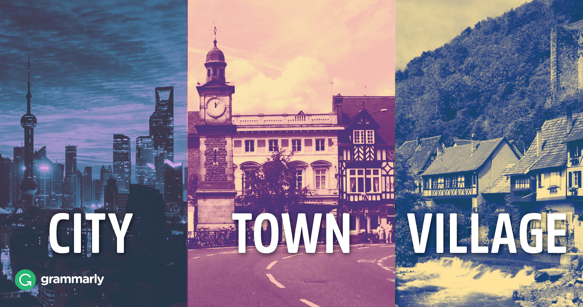
Unit 21 Speaking

Website: www.sinera.eu/English4U
Facebook: https://www.facebook.com/English4U1
Modal verb practice: Fill in can, have to, may, might, must, need, should or their negatives.
1. George has travelled a lot. He speak many languages.
2. I can hear you quite well. You not shout.
3. I'm not sure where I will go for my holidays, but I go to Italy.
4. She ride her bike at night without lights. It's not allowed.
5. She not eat so much chocolate because it's bad for her figure.
6. I understand him. He should speak louder.
7. It's later than I thought. I go now.
8. You find a better trainer if you want to improve yourself.
9. Talk to Ann about your problems. I'm sure she help you.
10. You not vacuum the carpets because Carol has already done it.
11. You be tired because you have worked very hard.
12. He come to my party because he is ill.
Your Town
Q: What is it like where you live?
A: I live in a residential area of a busy town in the south of my country. We have all needed facilities, such as good public transport and quite big shopping centre. At the same time it is starting to be developed with increasing number of infrastructures and establishments.
Q: Do you like living in the city?
A: Yes I do … I like going out with my friends and there are lots of lovely bars and restaurants within walking distance of my apartment … I’m a bit of a culture vulture as well so it’s great to have access to art exhibitions and that kind of thing …
Q: What do people in your town do?
A: Agriculture and fishing are common in my hometown. Also, with the presence of modernization, there are now many office jobs in my town
Q: Do you get many tourists visiting your area?
A: Not really no … I live in the inner-city and the area is a little run down … it’s basically a lot of high-rise flats and many of the shops are boarded up … so nothing to interest tourists really …
Q: Is it easy to travel around your hometown?
A: Yes, it is. It is a small city but there different kinds of transportation are available
Q: Would you prefer to live somewhere else? (Why?)
A: For the moment I’m happy living here, but at some point I’d like to live in a country with a warmer climate, and I’d like to live near a beach!
Writing…

